**Closing Prayer**

Leader:          As we gather this evening, we embrace and claim the darkness that is present both in the world and in our own lives.  As people who are familiar with the darkness, we also know that we gather to be illumined by the light of the Christ Child this Christmas season.  May the Christ Child, born in a lowly stable, himself an outcast, bring light, comfort, peace, and joy this holiday season.

May the hope of the Christ Child sustain us through this darkness.

**All:          *That together we may shine again.  Amen.***

**Hymn:  O come, O come, Emmanuel,**

*O come, Desire of nations, bind*  
*in one the hearts of humankind;*  
*bid thou our sad divisions cease,*  
*and be thyself our Prince of Peace.*  
*Rejoice! Rejoice!*  
*Emmanuel shall come to thee, O Israel*

*O come, O come, Emmanuel,*  
*and ransom captive Israel,*  
*that mourns in lonely exile here*  
*until the Son of God appear.*  
*Rejoice! Rejoice!*  
*Emmanuel shall come to thee, O Israel*

Thank you for joining us this evening.

Your presence brings a blessing to this chapel.

Please know that you and your loved ones will be remembered by

the Sisters of St. Joseph during these Advent and Christmas seasons.

God bless you.



**The People who walked in darkness have seen a great light**

Blue

Christmas

**Opening Hymn:  O come, O come Emmanuel**

*O come, O come, Emmanuel, and ransom captive Israel,*  
*that mourns in lonely exile here until the Son of God appear.*  
*Rejoice! Rejoice! Emmanuel shall come to you, O Israel.*

*O come, thou Wisdom from on high, who orders all things mightily;*  
*to us the path of knowledge show, and teach us in her ways to go.*  
*Rejoice! Rejoice! Emmanuel shall come to you, O Israel.*

Leader:       The Grace of our Lord Jesus Christ, the love of God, and the fellowship of the

Holy Spirit be with you all.

**All:*And also with you.***

Leader: Let us pray…

**All:*God of mercy, hear our prayer in this Advent season for ourselves and for our***

***families who live with painful thoughts and memories. We ask for strength for***

***today, courage for tomorrow and peace for the past. We ask these things in the***

***name of Christ, who shares our life in joy and sorrow, death and new birth,***

***despair and promise. Amen.***

THE LITURGY OF THE WORD

**Isaiah 40:1, 3-11,28-31**

**Psalm 121**

Leader:       I will lift up my eyes to the hills, from where is my help to come?

All:*My help comes from the Lord, the maker of heaven and earth*

Leader:       Who will not let your foot be moved and who watches over you will not fall asleep.

All:*Behold, the One who keeps watch over Israel shall neither slumber nor sleep.*

Leader:       The Lord himself watches over you; the Lord is your shade at your right hand.

All:*So that the sun shall not strike you by day, nor the moon by night*

Leader:       The Lord shall preserve you from all evil; it is the Lord who shall keep you safe.

All:*The Lord shall watch over your going out and your coming in, from this time forth for ever more.*

Leader:       Glory to you Creator of all, Word Made Flesh and Holy Spirit.

All:*As it was in the beginning, is now, and will be forever. Amen.*

**Prayers of the People**

Leader:       In the spirit of this season let us now confidently ask our God for all the good things we need: For ourselves as we participate in this Christmas as special people coping with our many different losses. God, hear our prayer.

**All:       *And in your mercy, answer.***

Leader:       For our families and friends, that they may continue to help and support us. God, hear our prayer.

**All:       *And in your mercy, answer****.*

Leader:       For any person we have loved who has died, for all the losses we know in our lives, that all may be redeemed by your Easter promise. God, hear our prayer.

**All:       *And in your mercy, answer.***

Leader:       For our family and friends, that you may bless them with love, peace, and joy. God, hear our prayer.

**All:       *And in your mercy, answer.***

Leader:       For peace throughout the world as proclaimed by the Christmas Angels on that faraway hillside. God, hear our prayer

**All:       *And in your mercy, answer.***

Leader:       For greater understanding of the lessons of love and acceptance as taught by Jesus your Christ. God, hear our prayer.

**All:       *And in your mercy, answer.***

Leader:          God of great compassion and love, listen to the prayers of these your people. Grant to all, especially the bereaved and troubled ones this Christmas, the blessing we ask in the name of Jesus, who taught us to pray

**All:          Our Father, who art in heaven, hallowed be thy Name, thy kingdom come, thy will be done, on earth as it is in heaven. Give us this day our daily bread. And forgive us our trespasses, as we forgive those who trespass against us. And lead us not into temptation, but deliver us from evil, for thine is the kingdom, and the power, and the glory, for ever and ever. Amen**

Fourth Candle:

Leader:       The fourth candle we light as a sign of hope, the hope that the Christmas story offers to us. We remember that God, who shares our life, promises us a place and time of no more pain and suffering.



All:         O God whose spirit is known by those whose hearts are thankful, and who makes cheerfulness a companion of strength, lift up our hearts, we pray, to a joyous confidence in your care. Guide us when we cannot see the way. May our lives bring comfort and encouragement to others. We ask it, in the name of Jesus Christ whose life is our light.      Amen.

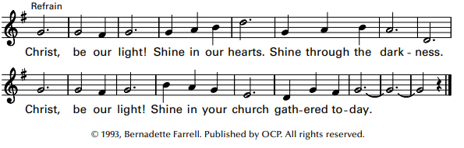

**Lighting of Individual Candles**

At this time, all are invited to come forward and light a candle. This candle is for you to take home with you, and burn it throughout this season of Advent. As you light the candle, remember that it is God who lights a candle in our darkness and holds us close until we are able to shine.

A short period of silence will follow.

All: Lord, God of Love, as we take our loved one by the hand, and present them to you, accept our love and Thanksgiving as we entrust them to be free and at home with you in your loving care. In the desolation of our journey when we feel like giving up, we ask for you to save us a place beside them and fill us with HOPE, motivation and energy in the days ahead.

**Matthew 11:28-30**

**Hymn: Christ Be Our Light**

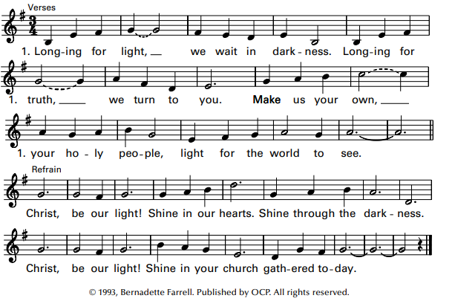

A LITURGY OF REMEMBRANCE



*Lighting*of *Four Advent Candles*

*First Candle:*

Leader:       The first candle we light to remember those persons whom we have loved and lost. We pause to remember their name, their voice, their face, the memory that binds them to us in this season. We hold them before God, giving thanks for their lives in ours.

Please take a moment to remember those who have died. I invite you to name them, aloud or in the silence of your hearts….

All: Thank you for the gift of each of these people in our lives and help us find joy in honoring and remembering the beautiful gifts you bestowed on them. We believe we will celebrate the treasure of their love again. Take our sad and aching hearts and comfort us for we feel hollow and empty. God of sorrow, draw us near! Amen!



Second Candle:



Leader:       The second candle we light is to redeem the pain of loss; the loss of relationships, the loss of jobs with the security they bring, the loss of health in ourselves or in family members, the loss of joy and peace in our lives from the stresses which surround us, the loss and loneliness we experience when our loved ones do not share our faith. As we gather up the pain of the past we offer it to you, 0 God, asking that into our open hands you will place the gift of peace.

Please take a moment to remember the losses. I invite you to name them, aloud or in the silence of your hearts….

All:               God of mystery, we turn our hearts to you. We come before you in need of peace, grateful for the mystery of life and ever keenly aware of your promises of guidance and protection. We want to place our trust in you, but our hearts grow fearful and anxious. Teach us to be patient with the transformation of our lives and to be open to the changes which we are now going through.   Amen.



Third Candle:



Leader:       The third candle we light for those who experience a loss of direction in their lives.

God of the Exodus, you led Moses and your people through the wilderness to a new land. Hear our prayer. We want so much to have a sense of direction, to know where we are and where we ought to be headed. But the darkness and the questions stay. You ask us to be full of faith, to believe deep within that you are our signpost, that you are our wisdom and our guide, and to trust in your presence. Your words to us are clear: “Do not fear, I go before you.”

Please take a moment to remember the losses. I invite you to name them, aloud or in the silence of your hearts….

All:               God of our depths, we cry out to you to be our guide. Help us to have a strong sense of inner direction and grant that we may have the reassurance of knowing that we are on the right path. Take our lives and use them according to your will. Take all that is lost in us and bring it home with you.      Amen.

